A Chronology Introducing United States Immigration Policy and Opinion, In Brevity 1880-2015
Austin R. Justice
Herein contained one will observe a chronologically ordered sequence of events, legislative acts, or otherwise which pertain to the immigration policies of the United States from 1880 unto 2015. Various public opinion polls are attached hereto in order to afford a sufficient comprehension of the common view of governmental doctrine.
1880 – 5.2 million immigrants flood the United States unto 1890.
1882 – The Federal Congress enacts the Chinese Exclusion Act, thereby restricting any Chinese natives from immigration and/or citizenship; furthermore it levies a head tax upon all immigrants.
1885 – It is declared wholly unlawful to import unskilled foreigners for labor; note: inapplicable to those who cross geographical land boundaries, i.e. Mexico and Canada.
1890 – Immigrants constitute circa 15% of the entire US population.
1891 – The Bureau of Immigration is established, and thereafter it is ordained that foreigners requiring monetary assistance in order to gain passage to North America cannot lawfully enter.
1892 – Ellis Island is opened to immigration services; unaccompanied women are deported.
1902 – The US Congress renews the Chinese Exclusion Act.
1903 – It is declared that any personages identified as anarchists, epileptics, polygamists or beggars cannot legally enter the US.
1907 – The immigrant head tax is raised; it is declared that unaccompanied children are to be deported, and likewise are those with physical or mental disabilities, as well as anybody retaining tuberculosis. Further, the government of Japan agrees to limit emigration of its citizens if the US desegregates Japanese and American students within San Francisco.
1917 – A literacy test as a requirement for admission is established, applicable to those exceeding the age of 16; the Asiatic Barred Zone comes into effect, thereby restricting any immigrants from Asia with the exception of Japan.
1921 – The US Congress enacts the Quota Act, thereby ordaining that immigration is to be restricted to 3% of each nationality present in 1910, therefore reducing European immigrants to .25 of their pre-First World War numbers; however, the act did not apply to immigrants of the Western Hemisphere and did not account for wives, learned professionals, domestic servants, or children of citizens.
1922 – Japanese nationals are deemed ineligible for immigration.
1924 – The quotas are modified to 2% of the immigrant figures of 1890 based upon surname, skewing results as many surnames were Anglicized upon entrance; despite outcry, Native Americans are unwillingly deemed US citizens; furthermore, the Border Patrol is established.
1929 – It is declared that the quotas of 1924 are permanent.
1943 – The Chinese Exclusion Act is repealed, and Chinese quotas are set at 105 annually.
1948 – The US Congress enacts the Displaced Persons Act, thereby allowing 205,000 refugees to enter as constituents of the quotas; priority is afforded to Baltic refugees, and there is discrimination against Jewish and Catholic refugees.
1952 – Refugee quotas are abandoned; the US Congress enacts the Immigration and Nationality act, thereby prohibiting race as a factor for immigration eligibility; Japanese quotas were established as 185, and other Asian states were granted 100 each; Northern and Western European quotas were ordained as 85% of collective immigrants; greater restrictions were enacted for British colonials due to an abnormally sizable amount of West Indian immigrants; husbands of American women are thereby also unaccounted as quotas.
1953 – The Displaced Persons Act is modified to allow 405,000 refugees.
1965 – US Congress enacts the Hart-Celler Act whereby origin quotas are discontinued, favoring a quota of 120,000 for the Western Hemisphere and 170,000 for the Eastern Hemisphere; priority is given to those with artistic ability, critical skills, familial ties and/or refugee status.
1978 – The Hemisphere quotas are abolished in favor of a global quota of 290,000.
1980 – US Congress enacts the Refugee Act whereby refugee status is repealed as a priority category; furthermore, the global quota is reduced to 270,000.
1986 – US Congress enacts the Immigration Control and Reform Act whereby amnesty is afforded to illegal aliens.
1989 – The US Congress grants permanent status to illegal registered nurses who have lived herein for circa three years and have met certification requirements.
1990 – The US Congress enacts the Immigration Act whereby unskilled workers were limited to 10,000 annually; immigrants constituted circa 7% of the US population collectively.
2000 – The US Congress enacts the Legal Immigration Family Equity Act, whereby amnesty is afforded to illegal aliens seeking green cards.
2001 – The US Congress enacts the USA Patriot Act, thereby amending the previous Immigration and Nationality Act to consider deportation of foreigners who: are representatives of any political/social group which publicly endorses terrorism and therefore undermines US anti-terrorism actions, have used positions to influence others in favor of terroristic acts, or have been affiliated with terroristic groups.
2002 – The US Congress enacts the Homeland Security Act whereby the Department of Homeland Security is established, assuming the responsibilities of the former Immigration and Naturalization Service.
2005, 2006, 2007 – The US Congress fails to pass proposed amnesty legislation: the Border Protection, Anti-Terrorism, and Illegal Immigration Control Act of 2005, the Comprehensive Immigration Reform Act of 2006, and the Comprehensive Immigration Reform Act of 2007; the latter thereof received bipartisan support, however ultimately failed due to unpopularity amongst the general public.
2014 – The US President Barack Obama issues an executive order whereby millions of illegal aliens would be granted temporary amnesty within the United States if they meet qualifications thereof.

Notes Regarding the Context of the Afore
In order to provide sufficient contextual comprehension, the following notes hereto have been added: the post-Civil War United States of 1866-1900 beheld a period of rapid industrialization wherein the primary forces utilized were immigrants, often German and/or Irish, or – in the circumstances of the Transcontinental Railroad – Chinese laborers. Due to European political upheaval, i.e. the attempted formation of a consolidated German state or Confederation, the US experienced an extensive influx of immigrants. Thus much of the population experienced a disdain thereto; signs of employment read Irish Need Not Apply; legislation of this period was partially a reaction to the afore.
The United States of the early-mid 20th century – with specificity, the Second World War – witnessed an immense distrust of particular foreign personages. Therefore, many Japanese, German, and Italian immigrants – including the often North American-born children thereof – were incarcerated within governmental camps. Such being established, one must furthermore note that due to the costly conflict the United States required allies; hence, legislation of this period reflects a greater tolerance of Allied foreign nationals. Also, due thereto, demands upon the US to harbor refugees increased.
The United States of the mid-late 20th century was gripped via the manners of McCarthyism and the so-called Cold War, wherein a strategic nuclear arms race had ensued between the American Federation and the Soviet Union. Therefore much the legislation hereof denotes a distrust of Soviet nationals, as well as a demand for refugee influx.
Concluding, the United States of our contemporary early 21st century entails a hostility towards groups regarded as terroristic, and – often mistakenly and with misinformation – Islamic individuals. Reasoning for such sentiment is derived via the prolonged War in Afghanistan and War in Iraq, as well as the events of September 11th, 2001. Further, primary immigration legislation is often directed toward individuals of the United Mexican States due to the increase of illegal aliens therefrom and the US involvement regarding the so called War on Drugs.

*The following poll hereupon is properly cited as the property of Gallup and is therefore included as reference and context; it is neither the work nor authorship of the author of this article.

Bibliography
"Immigration." Immigration. Accessed January 18, 2015. http://www.gallup.com/poll/1660/immigration.aspx?version=print.
"Gathering and Interactions of Peoples, Cultures, and Ideas." A Brief Timeline of U.S. Policy on Immigration and Naturalization. Accessed January 18, 2015. http://www.flowofhistory.org/themes/movement_settlement/uspolicytimeline.php.
Dill, Marshall. Germany: A Modern History. 1st ed. Vol. 1. Ann Arbor: Univ. of Michigan Press, 1961.
Rard, Albert Le. France: A Modern History. 1st ed. Vol. 1. Ann Arbor: University of Michigan Press, 1959.
"U.S. Immigration Since 1965." History.com. Accessed January 18, 2015. http://www.history.com/topics/us-immigration-since-1965.
"Historical Overview of Immigration Policy." Center for Immigration Studies. Accessed January 18, 2015. http://cis.org/ImmigrationHistoryOverview.
"Executive Actions on Immigration." Executive Actions on Immigration. Accessed January 18, 2015. http://www.uscis.gov/immigrationaction.

Gallup
IMMIGRATION

Immigration
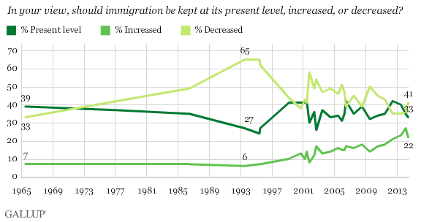
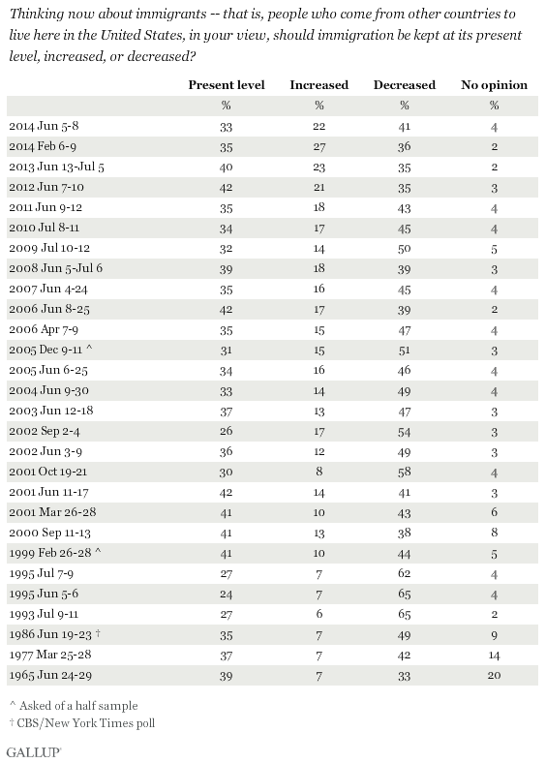
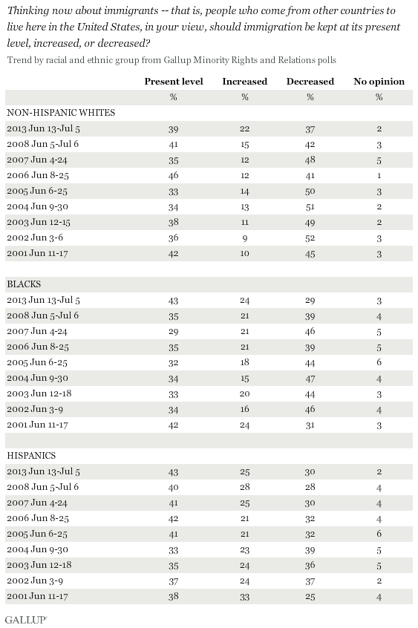
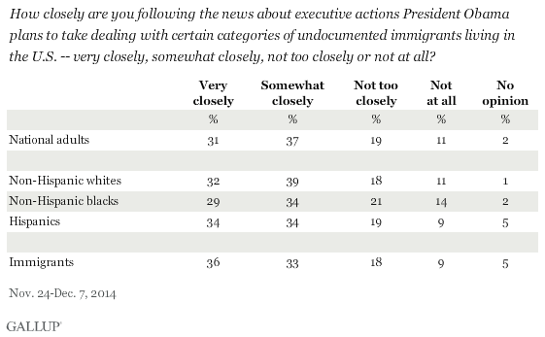
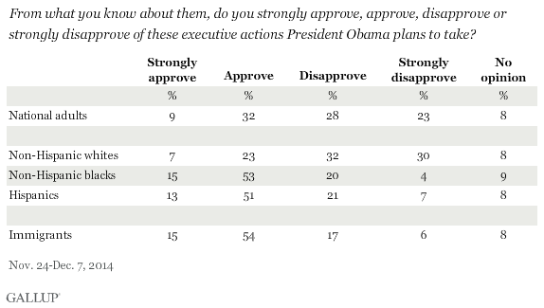
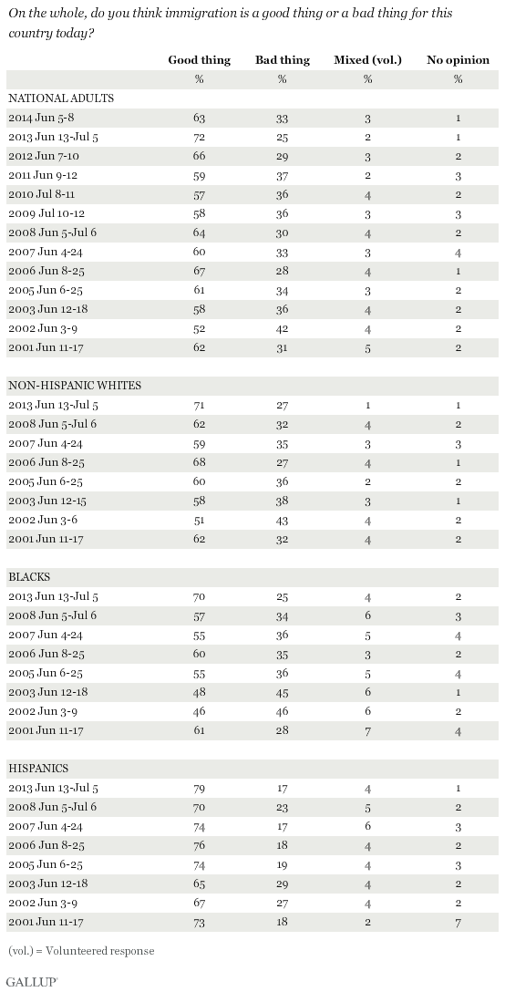
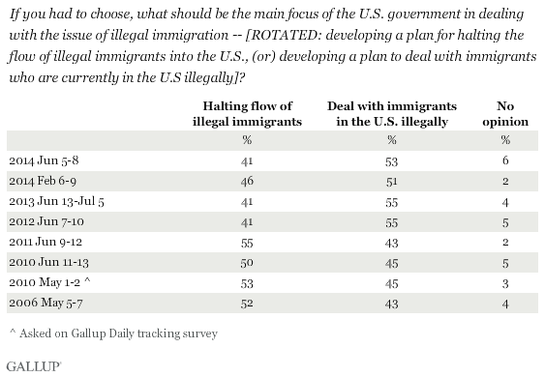
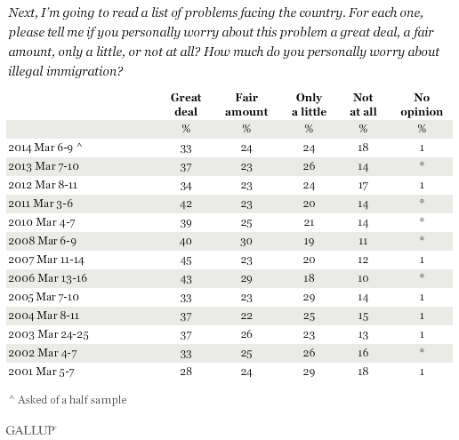
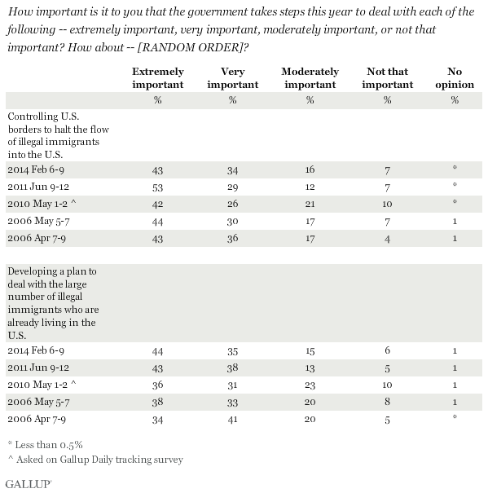
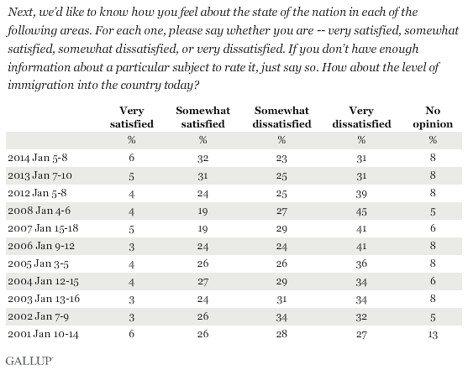
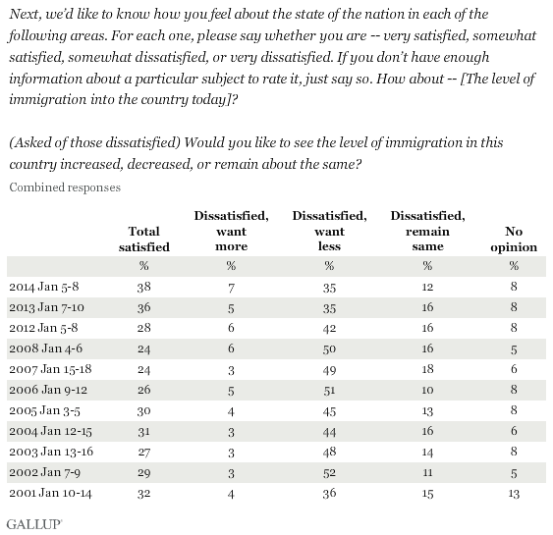
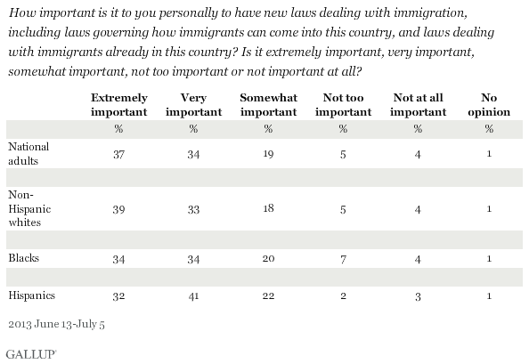
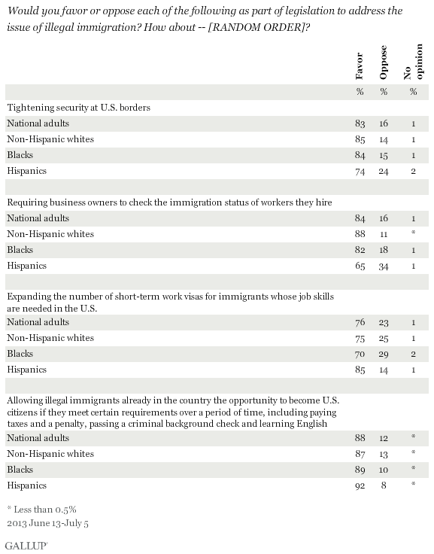
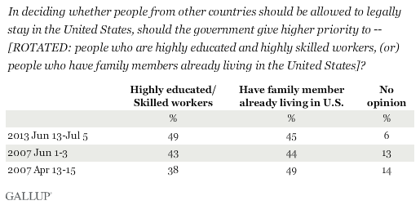
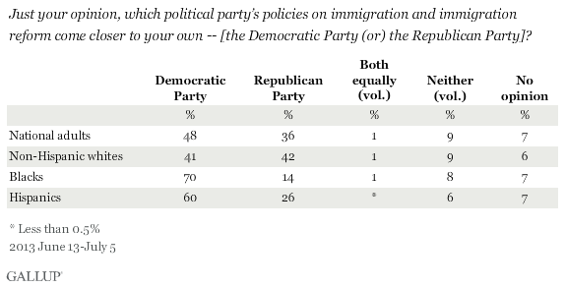
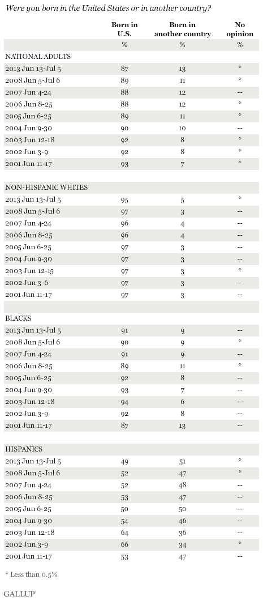
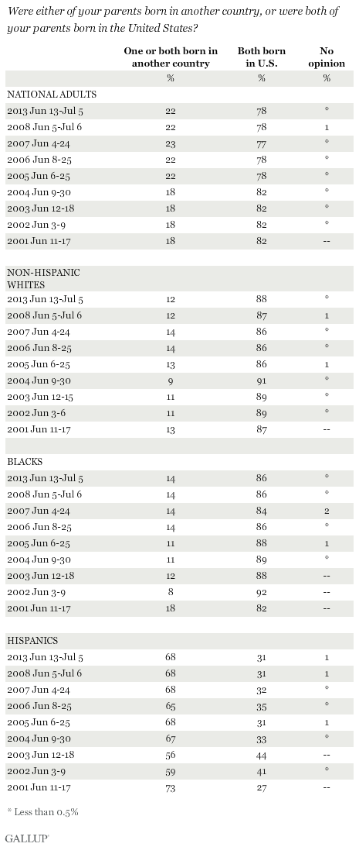
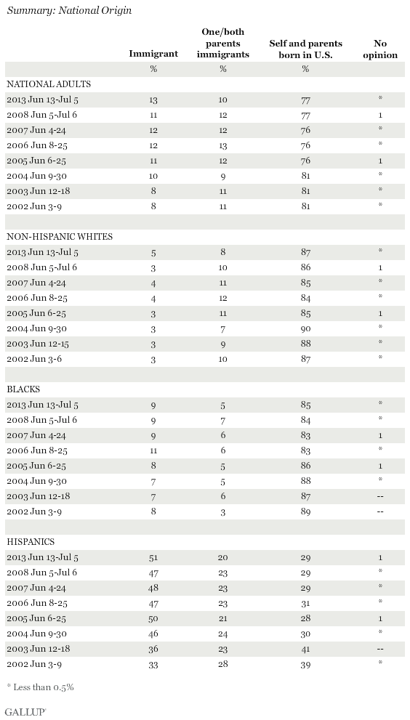
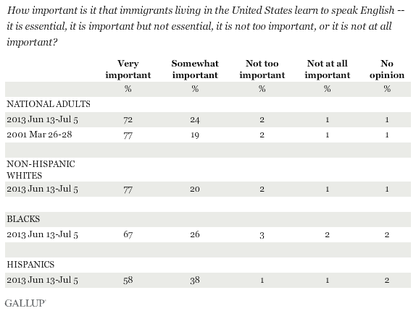
Which comes closest to your view about what government policy should be toward illegal immigrants currently residing in the United States? Should the government -- [ROTATED: deport all illegal immigrants back to their home country, allow illegal immigrants to remain in the United States in order to work, but only for a limited amount of time, or allow illegal immigrants to remain in the United States and become U.S. citizens, but only if they meet certain requirements over a period of time]?
 | Deport  all | Remain in  the U.S. in  order to  work | Remain in  the U.S.  and become  citizen | No  opinion
 | % | % | % | %
2011 Jun 9-12 | 21 | 13 | 64 | 2
2007 Mar 2-4 | 24 | 15 | 59 | 2
2006 Jun 8-25 | 16 | 17 | 66 | 1
2006 May 5-7 | 21 | 15 | 61 | 3
2006 Apr 7-9 | 18 | 17 | 63 | 2
Next, I'm going to read a list of actions Congress could take this year. Please say whether you strongly favor, favor, oppose, or strongly oppose Congress doing each of the following this year. How about -- [RANDOM ORDER]?
Pass a bill to give some illegal immigrants living in the U.S. a path to legal status
 | Strongly  favor | Favor | Oppose | Strongly  oppose | No  opinion
 | % | % | % | % | %
2011 Jan 14-16 | 13 | 30 | 25 | 30 | 2
Take steps to deny automatic citizenship to children born in the U.S. whose parents are illegal immigrants
 | Strongly  favor | Favor | Oppose | Strongly  oppose | No  opinion
 | % | % | % | % | %
2011 Jan 14-16 | 22 | 22 | 26 | 28 | 3
Which comes closer to your point of view -- [ROTATED: illegal immigrants in the long run become productive citizens and pay their fair share of taxes, (or) illegal immigrants cost the taxpayers too much by using government services like public education and medical services?]
 | Pay fair share  of taxes | Cost taxpayers  too much | Neither/Both/  No opinion
 | % | % | %
Total
2010 Jun 11-13 | 32 | 62 | 7
2008 Jun 5-Jul 6 | 31 | 63 | 6
2006 Jun 8-25 | 29 | 66 | 4
Non-Hispanic whites
2008 Jun 5-Jul 6 | 25 | 71 | 5
2006 Jun 8-25 | 22 | 74 | 3
Blacks
2008 Jun 5-Jul 6 | 29 | 62 | 10
2006 Jun 8-25 | 37 | 56 | 6
Hispanics
2008 Jun 5-Jul 6 | 65 | 30 | 5
2006 Jun 8-25 | 65 | 31 | 3
Which comes closer to your view -- [ROTATED: illegal immigrants mostly take jobs that American workers want, (or) illegal immigrants mostly take low-paying jobs Americans don't want]?
 | Take jobs  American  workers want | Take low-paying  jobs Americans  don't want | Neither/Both/  No opinion
 | % | % | %
Total
2008 Jun 5-Jul 6 | 15 | 79 | 7
2006 Jun 8-25 | 17 | 74 | 10
Non-Hispanic whites
2008 Jun 5-Jul 6 | 16 | 79 | 6
2006 Jun 8-25 | 18 | 74 | 9
Blacks
2008 Jun 5-Jul 6 | 20 | 70 | 9
2006 Jun 8-25 | 24 | 67 | 10
Hispanics
2008 Jun 5-Jul 6 | 9 | 87 | 4
2006 Jun 8-25 | 13 | 81 | 7
(Asked of a half sample) In your view, what should be the higher priority in dealing with the issue of illegal immigration -- [ROTATED: developing a plan for halting the flow of illegal immigrants into the U.S., (or) developing a plan to deal with illegal immigrants who are already in the U.S.], or should both be given the same priority?
 | Halting the  flow of  illegal  immigrants | Deal with  illegal  immigrants  already in U.S. | Both the  same priority | No  opinion
2007 Jul 6-8 | 20% | 25 | 53 | 2
(Asked of a half sample) In terms of laws dealing with illegal immigration in the United States, which of the following would you prefer to see happen -- [ROTATED: enforce the current laws more strictly and NOT pass new laws (or) pass new laws in addition to enforcing the current laws more strictly]?
 | Enforce  current laws | Pass  new laws | No  opinion
2007 Jul 6-8 | 46% | 50 | 4
(Asked of Republicans and independents who lean to the Republican Party) Has George W. Bush's recent handling of the immigration issue caused you to -- [ROTATED: gain confidence in Bush, has it not affected your opinion either way, or has it caused you to lose confidence in Bush]?
 | Gain  confidence | Not affected  opinion | Lose  confidence | No  opinion
2007 Jul 6-8 | 10% | 51 | 39 | --
For each of the following areas, please say whether immigrants to the United States are making the situation in the country better or worse, or not having much effect. How about -- [RANDOM ORDER]?
A. The crime situation
 | Better | Worse | Not much  effect | No opinion
 | % | % | % | %
Total
2007 Jun 4-24 | 4 | 58 | 34 | 4
2004 Jun 9-30 | 6 | 47 | 43 | 4
2002 Jun 3-9 | 8 | 50 | 37 | 5
2001 Jun 11-17 | 7 | 50 | 38 | 5
Non-Hispanic whites
2007 Jun 4-24 | 2 | 63 | 31 | 4
2004 Jun 9-30 | 4 | 49 | 45 | 2
2002 Jun 3-6 | 6 | 52 | 37 | 5
2001 Jun 11-17 | 5 | 54 | 37 | 4
Blacks
2007 Jun 4-24 | 3 | 52 | 40 | 5
2004 Jun 9-30 | 5 | 44 | 45 | 6
2002 Jun 3-9 | 9 | 49 | 37 | 5
2001 Jun 11-17 | 9 | 44 | 41 | 6
Hispanics
2007 Jun 4-24 | 11 | 41 | 41 | 7
2004 Jun 9-30 | 12 | 44 | 36 | 8
2002 Jun 3-9 | 18 | 41 | 34 | 7
2001 Jun 11-17 | 12 | 47 | 33 | 8
B. Job opportunities for you and your family
 | Better | Worse | Not much  effect | No  opinion
 | % | % | % | %
Total
2007 Jun 4-24 | 12 | 34 | 52 | 2
2004 Jun 9-30 | 11 | 37 | 51 | 1
2002 Jun 3-9 | 14 | 37 | 46 | 3
2001 Jun 11-17 | 15 | 31 | 50 | 4
Non-Hispanic whites
2007 Jun 4-24 | 7 | 34 | 57 | 2
2004 Jun 9-30 | 6 | 38 | 55 | 1
2002 Jun 3-6 | 10 | 37 | 50 | 3
2001 Jun 11-17 | 12 | 32 | 53 | 3
Blacks
2007 Jun 4-24 | 11 | 49 | 37 | 3
2004 Jun 9-30 | 9 | 49 | 39 | 3
2002 Jun 3-9 | 14 | 48 | 36 | 2
2001 Jun 11-17 | 20 | 38 | 41 | 1
Hispanics
2007 Jun 4-24 | 37 | 21 | 39 | 3
2004 Jun 9-30 | 34 | 28 | 36 | 2
2002 Jun 3-9 | 39 | 25 | 33 | 3
2001 Jun 11-17 | 42 | 18 | 37 | 3
C. Food, music, and the arts
 | Better | Worse | Not much  effect | No  opinion
 | % | % | % | %
Total
2007 Jun 4-24 | 40 | 9 | 46 | 4
2004 Jun 9-30 | 44 | 10 | 42 | 4
2002 Jun 3-9 | 54 | 10 | 31 | 5
2001 Jun 11-17 | 58 | 8 | 29 | 5
Non-Hispanic whites
2007 Jun 4-24 | 37 | 8 | 51 | 5
2004 Jun 9-30 | 42 | 11 | 43 | 4
2002 Jun 3-6 | 53 | 10 | 32 | 5
2001 Jun 11-17 | 59 | 8 | 28 | 5
Blacks
2007 Jun 4-24 | 34 | 14 | 46 | 6
2004 Jun 9-30 | 29 | 12 | 56 | 3
2002 Jun 3-9 | 47 | 11 | 37 | 5
2001 Jun 11-17 | 54 | 10 | 33 | 3
Hispanics
2007 Jun 4-24 | 65 | 5 | 28 | 1
2004 Jun 9-30 | 65 | 5 | 27 | 3
2002 Jun 3-9 | 69 | 5 | 21 | 5
2001 Jun 11-17 | 72 | 3 | 23 | 2
D. The economy in general
 | Better | Worse | Not much  effect | No  opinion
 | % | % | % | %
Total
2007 Jun 4-24 | 28 | 46 | 23 | 3
2004 Jun 9-30 | 22 | 41 | 34 | 3
2002 Jun 3-9 | 32 | 36 | 28 | 4
2001 Jun 11-17 | 32 | 32 | 31 | 5
Non-Hispanic whites
2007 Jun 4-24 | 24 | 49 | 24 | 3
2004 Jun 9-30 | 18 | 42 | 37 | 3
2002 Jun 3-6 | 29 | 37 | 30 | 4
2001 Jun 11-17 | 29 | 34 | 32 | 5
Blacks
2007 Jun 4-24 | 22 | 52 | 21 | 5
2004 Jun 9-30 | 16 | 47 | 31 | 6
2002 Jun 3-9 | 25 | 47 | 24 | 4
2001 Jun 11-17 | 27 | 39 | 31 | 3
Hispanics
2007 Jun 4-24 | 55 | 25 | 17 | 3
2004 Jun 9-30 | 48 | 29 | 20 | 3
2002 Jun 3-9 | 53 | 22 | 23 | 2
2001 Jun 11-17 | 42 | 23 | 29 | 6
E. Taxes
 | Better | Worse | Not much  effect | No  opinion
 | % | % | % | %
Total
2007 Jun 4-24 | 11 | 55 | 28 | 6
2004 Jun 9-30 | 12 | 45 | 38 | 5
2002 Jun 3-9 | 12 | 50 | 31 | 7
2001 Jun 11-17 | 12 | 46 | 34 | 8
Non-Hispanic whites
2007 Jun 4-24 | 5 | 59 | 30 | 6
2004 Jun 9-30 | 8 | 46 | 42 | 4
2002 Jun 3-6 | 9 | 52 | 32 | 7
2001 Jun 11-17 | 10 | 48 | 34 | 8
Blacks
2007 Jun 4-24 | 10 | 54 | 29 | 7
2004 Jun 9-30 | 10 | 48 | 34 | 8
2002 Jun 3-9 | 14 | 54 | 25 | 7
2001 Jun 11-17 | 12 | 50 | 32 | 6
Hispanics
2007 Jun 4-24 | 42 | 34 | 19 | 5
2004 Jun 9-30 | 34 | 34 | 25 | 7
2002 Jun 3-9 | 29 | 31 | 33 | 7
2001 Jun 11-17 | 40 | 26 | 25 | 9
F. Social and moral values
 | Better | Worse | Not much  effect | No  opinion
 | % | % | % | %
Total
2007 Jun 4-24 | 19 | 37 | 41 | 3
2004 Jun 9-30 | 18 | 27 | 50 | 5
2002 Jun 3-9 | 25 | 30 | 39 | 6
2001 Jun 11-17 | 25 | 26 | 45 | 4
Non-Hispanic whites
2007 Jun 4-24 | 14 | 40 | 42 | 3
2004 Jun 9-30 | 14 | 29 | 51 | 6
2002 Jun 3-6 | 22 | 32 | 41 | 5
2001 Jun 11-17 | 22 | 29 | 45 | 4
Blacks
2007 Jun 4-24 | 18 | 31 | 46 | 5
2004 Jun 9-30 | 16 | 23 | 55 | 6
2002 Jun 3-9 | 27 | 31 | 34 | 8
2001 Jun 11-17 | 26 | 20 | 50 | 4
Hispanics
2007 Jun 4-24 | 42 | 19 | 35 | 4
2004 Jun 9-30 | 38 | 21 | 37 | 4
2002 Jun 3-9 | 39 | 17 | 37 | 7
2001 Jun 11-17 | 45 | 17 | 34 | 4
How closely have you been following the news about proposed legislation to deal with the issue of illegal immigration in the United States -- very closely, somewhat closely, not too closely, or not at all?
 | Very  closely | Somewhat  closely | Not too  closely | Not  at all | No  opinion
Total
2007 Jun 4-24 | 23% | 47 | 23 | 6 | *
Non-Hispanic whites
2007 Jun 4-24 | 21% | 51 | 23 | 5 | *
Blacks
2007 Jun 4-24 | 25% | 34 | 24 | 15 | 1
Hispanics
2007 Jun 4-24 | 25% | 43 | 23 | 8 | 1
* Less than 0.5%
Based on what you have heard or read, do you approve or disapprove of the government's recent efforts to deal with illegal immigration in the U.S.?
 | Approve | Disapprove | No opinion
Total
2007 Jun 4-24 | 32% | 61 | 7
Non-Hispanic whites
2007 Jun 4-24 | 32% | 60 | 8
Blacks
2007 Jun 4-24 | 29% | 60 | 11
Hispanics
2007 Jun 4-24 | 37% | 58 | 5
Do you think the United States should -- or should not -- require immigrants who come to this country to be proficient in English as a condition for remaining in the U.S.?
 | Yes,  should | No,  should not | No  opinion
Total
2007 Jun 4-24 | 77% | 22 | 1
Non-Hispanic whites
2007 Jun 4-24 | 80% | 18 | 2
Blacks
2007 Jun 4-24 | 76% | 22 | 2
Hispanics
2007 Jun 4-24 | 59% | 40 | 1
As you may know, Senate leaders and the president recently agreed on a bill dealing with the issue of illegal immigration. The legislation will be debated in Congress this coming week.
How closely have you been following the news about this proposed bill to deal with the issue of illegal immigration -- very closely, somewhat closely, not too closely, or not at all?
 | Very  closely | Somewhat  closely | Not too  closely | Not  at all | No  opinion
2007 Jun 1-3 | 18% | 42 | 28 | 12 | --
Based on what you have heard or read about it, do you favor or oppose this proposed bill, or don't you know enough to say?
 | Favor | Oppose | Don't know  enough to  say | No  answer
2007 Jun 1-3 | 11% | 30 | 58 | 1
(Asked of those who either favor or oppose the proposed immigration bill) Do you [favor/oppose] this bill strongly or only moderately?
COMBINED RESPONSES: BASED ON NATIONAL ADULTS
 | Favor,  strongly | Favor,  only  moderately | Oppose,  only  moderately | Oppose,  strongly | Don't  know  enough  to say | No  answer
2007 Jun 1-3 | 4% | 7 | 12 | 18 | 58 | 1
(Asked of those who favor the proposed immigration bill) What are the main reasons why you favor this bill? [OPEN-ENDED]
2007
Jun 1-3
 | %
Agree with requirements illegal immigrants  must meet to stay in the U.S/become citizens | 28
Need to do something to address issue | 21
Helps control who can come into the U.S./sets limits | 18
Good/Fair compromise/best that can be achieved | 14
Impractical to send all illegal immigrants already here back to their home country | 13
Need works over here to do jobs Americans won't do | 9
Other | 2
No reason in particular (vol.) | --
No opinion | 9
Percentages add to more than 100% due to multiple responses
(vol.) = Volunteered response
(Asked of those who oppose the proposed immigration bill) What are the main reasons why you oppose this bill? [OPEN-ENDED]
2007
Jun 1-3
 | %
Grants amnesty to illegal immigrants/Should not reward those who came illegally | 39
Bill should have stronger/stiffer penalties for illegal immigrants | 17
New laws won't work/won't take care of the problem | 15
Immigrants cost taxpayers too much by using health, welfare, school services | 11
Too many people in the U.S. already/should not allow so many in | 10
Taking jobs from American workers | 7
Penalties/Fines on immigrants are too stiff | 7
Need to do more about border security | 6
Other | 6
No reason in particular (vol.) | 1
No opinion | 1
(vol.) = Volunteered response
Percentages add to more than 100% due to multiple responses
Now thinking about immigrants who come to the United States illegally, which comes closest to your view about what the government policy should be toward illegal immigrants currently residing in the United States? Should the government -- [ROTATED: require illegal immigrants to leave the U.S. and not allow them to return, require illegal immigrants to leave the U.S., but allow them to return temporarily to work, require illegal immigrants to leave the U.S., but allow them to return and become U.S. citizens if they meet certain requirements over a period of time, (or) allow illegal immigrants to remain in the United States and become U.S. citizens if they meet certain requirements over a period of time]?
2007
Apr 13-15
 | %
Require to leave, not allow to return | 14
Require to leave, allow to return temporarily to work | 6
Require to leave, allow to return and become citizens if requirements met | 42
Allow to remain in the U.S. and become citizens if requirements met | 36
No opinion | 2
Do you think the U.S. has made progress or lost ground in dealing with illegal immigration in the past year, or has there been no change?
 | Made  progress | Lost  ground | No  change | No  opinion
2007 Apr 13-15 | 12% | 43 | 42 | 3
Next, as you may know, the government is considering issuing new tamper-proof Social Security cards as a way for people to prove they are eligible to work in the United States. Would you favor or oppose requiring people to show this card in order to get a job in the U.S.?
 | Favor | Oppose | No opinion
2007 Mar 2-4 | 86% | 10 | 3
Do you think -- [ITEMS ROTATED] -- [ROTATED: has/have gone too far, has/have been about right, or has/have not gone far enough] -- in dealing with the issue of illegal immigration?
A. The federal government
 | Too  far | About  right | Not far  enough | No  opinion
2007 Mar 2-4 | 9% | 12 | 76 | 3
B. State and local governments
 | Too  far | About  right | Not far  enough | No  opinion
2007 Mar 2-4 | 10% | 16 | 69 | 5
Do you think the number of immigrants now entering the U.S. from each of the following areas is too many, too few, or about the right amount -- how about immigrants from -- [RANDOM ORDER]?
A. European countries
 | Too many | Too few | About  right | No  opinion
 | % | % | % | %
Total
2006 Jun 8-25 | 20 | 17 | 56 | 8
2002 Jun 3-9 | 25 | 12 | 53 | 10
Non-Hispanic whites
2006 Jun 8-25 | 17 | 17 | 60 | 7
2002 Jun 3-6 | 25 | 9 | 57 | 9
Blacks
2006 Jun 8-25 | 27 | 11 | 53 | 9
2002 Jun 3-9 | 31 | 17 | 43 | 9
Hispanics
2006 Jun 8-25 | 16 | 22 | 49 | 13
2002 Jun 3-9 | 26 | 20 | 44 | 10
FULL NATIONAL ADULT TREND
 | Too many | Too few | About  right | No  opinion
 | % | % | % | %
2006 Jun 8-25 | 20 | 17 | 56 | 8
2002 Jun 3-9 | 25 | 12 | 53 | 10
1993 Jul 9-11 | 33 | 10 | 52 | 5
1992 Feb 6-9 | 36 | 7 | 52 | 5
1984 Jun 1-3 | 26 | 11 | 50 | 13
B. Latin American countries
 | Too many | Too few | About  right | No  opinion
 | % | % | % | %
Total
2006 Jun 8-25 | 48 | 6 | 40 | 6
2002 Jun 3-9 | 46 | 5 | 41 | 8
Non-Hispanic whites
2006 Jun 8-25 | 46 | 5 | 43 | 6
2002 Jun 3-6 | 46 | 4 | 42 | 8
Blacks
2006 Jun 8-25 | 46 | 9 | 39 | 7
2002 Jun 3-9 | 40 | 12 | 40 | 8
Hispanics
2006 Jun 8-25 | 55 | 9 | 31 | 5
2002 Jun 3-9 | 50 | 11 | 35 | 4
FULL NATIONAL ADULT TREND
 | Too many | Too few | About  right | No  opinion
 | % | % | % | %
2006 Jun 8-25 | 48 | 6 | 40 | 6
2002 Jun 3-9 | 46 | 5 | 41 | 8
1993 Jul 9-11 | 62 | 5 | 29 | 4
1992 Feb 6-9 | 69 | 5 | 22 | 4
1984 Jun 1-3 | 53 | 5 | 30 | 12
C. African countries
 | Too many | Too few | About  right | No  opinion
 | % | % | % | %
Total
2006 Jun 8-25 | 19 | 20 | 53 | 8
2002 Jun 3-9 | 29 | 13 | 48 | 10
Non-Hispanic whites
2006 Jun 8-25 | 17 | 16 | 59 | 8
2002 Jun 3-6 | 31 | 9 | 51 | 9
Blacks
2006 Jun 8-25 | 16 | 35 | 43 | 6
2002 Jun 3-9 | 28 | 26 | 40 | 6
Hispanics
2006 Jun 8-25 | 19 | 29 | 39 | 13
2002 Jun 3-9 | 18 | 24 | 44 | 14
FULL NATIONAL ADULT TREND
 | Too many | Too few | About  right | No  opinion
 | % | % | % | %
2006 Jun 8-25 | 19 | 20 | 53 | 8
2002 Jun 3-9 | 29 | 13 | 48 | 10
1993 Jul 9-11 | 44 | 9 | 40 | 7
1992 Feb 6-9 | 47 | 10 | 36 | 7
1984 Jun 1-3 | 31 | 12 | 37 | 20
D. Asian countries
 | Too many | Too few | About  right | No  opinion
 | % | % | % | %
Total
2006 Jun 8-25 | 31 | 7 | 54 | 9
2002 Jun 3-9 | 39 | 5 | 47 | 9
Non-Hispanic whites
2006 Jun 8-25 | 29 | 5 | 57 | 8
2002 Jun 3-6 | 38 | 4 | 49 | 9
Blacks
2006 Jun 8-25 | 33 | 13 | 45 | 8
2002 Jun 3-9 | 47 | 7 | 39 | 7
Hispanics
2006 Jun 8-25 | 32 | 13 | 42 | 13
2002 Jun 3-9 | 34 | 15 | 41 | 10
FULL NATIONAL ADULT TREND
 | Too many | Too few | About  right | No  opinion
 | % | % | % | %
2006 Jun 8-25 | 31 | 7 | 54 | 9
2002 Jun 3-9 | 39 | 5 | 47 | 9
1993 Jul 9-11 | 62 | 4 | 29 | 5
1992 Feb 6-9 | 58 | 4 | 32 | 6
1984 Jun 1-3 | 49 | 6 | 33 | 12
E. Arab countries
 | Too many | Too few | About  right | No  opinion
 | % | % | % | %
Total
2006 Jun 8-25 | 39 | 12 | 38 | 11
2002 Jun 3-9 | 54 | 5 | 33 | 8
Non-Hispanic whites
2006 Jun 8-25 | 39 | 11 | 39 | 10
2002 Jun 3-6 | 56 | 3 | 33 | 8
Blacks
2006 Jun 8-25 | 39 | 15 | 36 | 10
2002 Jun 3-9 | 52 | 8 | 32 | 8
Hispanics
2006 Jun 8-25 | 31 | 18 | 36 | 14
2002 Jun 3-9 | 46 | 16 | 28 | 10
FULL NATIONAL ADULT TREND
 | Too many | Too few | About  right | No  opinion
 | % | % | % | %
2006 Jun 8-25 | 39 | 12 | 38 | 11
2002 Jun 3-9 | 54 | 5 | 33 | 8
1993 Jul 9-11 | 64 | 6 | 24 | 6
As you may know, Congress is considering new laws to deal with the issue of illegal immigration. What concerns you more -- that the new laws will go too far -- or will not go far enough -- to [ITEMS ROTATED]?
A. Increase security along the U.S. border with Mexico
 | Will go  too far | Will not go  far enough | No  opinion
 | % | % | %
Total
2006 Jun 8-25 | 31 | 66 | 3
Non-Hispanic whites
2006 Jun 8-25 | 28 | 69 | 3
Blacks
2006 Jun 8-25 | 30 | 67 | 3
Hispanics
2006 Jun 8-25 | 50 | 43 | 7
B. Develop a plan to deal with the large number of illegal immigrants who are already living in the U.S.
 | Will go  too far | Will not go  far enough | No  opinion
 | % | % | %
Total
2006 Jun 8-25 | 28 | 66 | 6
Non-Hispanic whites
2006 Jun 8-25 | 24 | 70 | 6
Blacks
2006 Jun 8-25 | 33 | 61 | 6
Hispanics
2006 Jun 8-25 | 42 | 54 | 3
How sympathetic would you say you are toward illegal immigrants in the United States -- [ROTATED: very sympathetic, somewhat sympathetic, somewhat unsympathetic, (or) very unsympathetic]?
 | Very  sympathetic | Somewhat  sympathetic | Somewhat  unsympathetic | Very  unsympathetic | No  opinion
2006 May 5-7 | 17% | 46 | 18 | 16 | 3
Which comes closer to your view -- [ROTATED: if the U.S. government took the right steps, it could effectively control illegal immigration to the U.S., (or) no matter what the U.S. government does, it will not be able to control the number of illegal immigrants who are able to get into the U.S.]?
 | Could  control illegal  immigration | Will not be able  to control illegal  immigration | No  opinion
2006 May 5-7 | 62% | 34 | 4
Suppose the government does allow illegal immigrants to remain in the United States legally and permanently if they meet certain requirements. For each of the following, please say whether it should or should not be a requirement. First, the immigrant -- [RANDOM ORDER]?
A. Must have lived in the United States for at least five years
 | Yes, should | No, should not | No opinion
2006 May 5-7 | 74% | 24 | 2
2006 Apr 7-9 ^ | 67% | 30 | 3
^ Asked of a half sample
B. Must pay a fine for coming to the United States illegally
 | Yes, should | No, should not | No opinion
2006 May 5-7 | 57% | 40 | 3
2006 Apr 7-9 ^ | 64% | 34 | 1
^ Asked of a half sample
C. Must learn to speak English
 | Yes, should | No, should not | No opinion
2006 May 5-7 | 89% | 10 | *
2006 Apr 7-9 ^ | 85% | 14 | 1
* Less than 0.5%
^ Asked of a half sample
Do you favor or oppose each of the following proposals as a way to reduce illegal immigration to the United States? How about -- [RANDOM ORDER]?
A. Building a wall along the border with Mexico
 | Favor | Oppose | No opinion
2006 May 5-7 | 42% | 56 | 2
B. Prohibiting children of illegal immigrants from attending U.S. public schools
 | Favor | Oppose | No opinion
2006 May 5-7 | 32% | 65 | 4
Suppose U.S. authorities were able to remove almost all illegal immigrants from the U.S. What effect do you think this would have on the U.S. economy? Do you think it would have a -- [ROTATED: very positive effect, somewhat positive, neither positive nor negative, somewhat negative, (or a) very negative effect] -- on the U.S. economy?
 | Very  positive | Some-  what  positive | Neither | Some-  what  negative | Very  negative | No  opinion
2006 May 5-7 | 12% | 20 | 16 | 30 | 19 | 2
How much contact do you, personally, have with recent immigrants -- a great deal, a moderate amount, not much, or none at all?
 | Great  deal | Moderate  amount | Not  much | None  at all | No  opinion
2006 May 5-7 | 14% | 34 | 34 | 17 | *
* Less than 0.5%
Do you know for a fact, or do you suspect, that any of those recent immigrants are in the United States illegally, or do you not suspect it?
[ASKED OF ADULTS WHO HAVE HAD CONTACT WITH RECENT IMMIGRANTS]
 | Know or suspect  immigrants here  illegally | Do not suspect  immigrants are  here illegally | No  opinion
2006 May 5-7 | 53% | 38 | 8
Do you think that illegal immigration to the United States is out of control, or not?
 | Yes, out  of control | No,  not | No  opinion
2006 Apr 7-9 | 81% | 16 | 3
Do you think the United States government should -- or should not -- make illegal immigration a crime?
[ASKED OF A HALF SAMPLE]
 | Yes, should | No, should not | No opinion
2006 Apr 7-9 | 61% | 35 | 4
Do you think the government should -- or should not -- make it a crime for U.S. citizens to provide assistance to people they know are illegal immigrants?
[ASKED OF A HALF SAMPLE]
 | Yes, should | No, should not | No opinion
2006 Apr 7-9 | 52% | 43 | 5
Next, thinking about people who come to the U.S. from other countries on temporary work visas, what do you think the government should do about the work opportunities available for those people? Should the government -- [ROTATED: expand those work opportunities, keep them about the same, or reduce those work opportunities]?
 | Expand | Keep  the same | Reduce | No opinion
2006 Apr 7-9 | 16% | 53 | 27 | 4
Gallup http://www.gallup.com/poll/1660/immigration.aspxGallup World Headquarters, 901 F Street, Washington, D.C., 20001, U.S.A+1 202.715.3030
Copyright © 2015 Gallup, Inc. All rights reserved.
Gallup, Inc. maintains several registered and unregistered trademarks that include but may not be limited to: A8, Accountability Index, Business Impact Analysis, BE10, CE11, CE11 Accelerator, Clifton StrengthsExplorer, Clifton StrengthsFinder, Customer Engagement Index, Customer Engagement Management, Dr. Gallup Portrait, Employee Engagement Index, Enetrix, Engagement Creation Index, Follow This Path, Gallup, Gallup Brain, Gallup Business Journal, GBJ, Gallup Consulting, Gallup-Healthways Well-Being Index, Gallup Management Journal, GMJ, Gallup Panel, Gallup Press, Gallup Tuesday Briefing, Gallup University, Gallup World News, HumanSigma, HumanSigma Accelerator, ICE11, I10, L3, ME25, NurseInsight, NurseStrengths, Patient Quality System, Performance Optimization, Power of 2, PrincipalInsight, Q12, Q12 Accelerator, Q12 Advantage, Selection Research, Inc., SE25, SF34, SRI, Soul of the City, Strengths Spotlight, Strengths-Based Selling, StatShot, StrengthsCoach, StrengthsExplorer, StrengthsFinder, StrengthsInsight, StrengthsQuest, SupportInsight, TX(R+E+R)=P3, TeacherInsight, The Gallup Path, The Gallup Poll, The Gallup School, VantagePoint, Varsity Management, Wellbeing Finder, Achiever, Activator, Adaptability, Analytical, Arranger, Belief, Command, Communication, Competition, Connectedness, Consistency, Context, Deliberative, Developer, Discipline, Empathy, Fairness, Focus, Futuristic, Harmony, Ideation, Includer, Individualization, Input, Intellection , Learner, Maximizer, Positivity, Relator, Responsibility, Restorative, Self-Assurance, Significance, Strategic, and Woo. All other trademarks are the property of their respective owners. These materials are provided for noncommercial, personal use only. Reproduction prohibited without the express permission of Gallup, Inc.

